## IITB EdTech Internship TRACK 2

## Educational Product/Application Development

## (Fullstack)

## Primary Report

## on

## Problem Identification, Validation, and Prototype Development for an Educational Application”

**GROUP DETAILS**

|  |  |  |  |  |  |  |
| --- | --- | --- | --- | --- | --- | --- |
| **Group Name:** | | | | | | |
| **Sr.** | **Students Name** | **Intern_ID** | **Juno_ID** | **Dept.** | **Class** | **Roll No.** |
| 1 | **Saniya Mohan Salunkhe** |  |  | CSE | T.Y(A) | 80 |
| 2 | Arpti Anil Koli |  |  | CSE | T.Y(A) |  |
| 3 |  |  |  | CSE | T.Y(B) |  |
| 4 |  |  |  | CSE | T.Y(B) |  |
| **Faculty Mentor Name:** | | | | | | |

### 

### Section 1: Problem Identification and User Research

**1.1Identified Problems**

**Problem 1: Students and Teachers Use Too Many Different Apps**

In many coaching classes, schools, and online courses, students and teachers use different platforms for different learning activities. For example, teachers share video lectures on YouTube, send notes through WhatsApp or Google Drive, conduct quizzes using Google Forms, and provide certificates using Canva or some PDF tool. Students must switch between 4–5 different apps to complete one single course. This makes learning complicated and stressful. It is hard to remember which app had the video, where the quiz link was sent, and where to find the notes.

For teachers, the process is even more difficult. They spend a lot of time organizing links, preparing content, sending reminders, and handling everything separately. This increases their workload and reduces teaching quality. Students feel lost, skip lessons, or forget to complete quizzes. They get demotivated and may stop learning completely. A single platform with all tools in one place would make it easier for both students and teachers to manage the course.

**Why it matters:** Learning becomes confusing and time-consuming when different tools are used for everything. A combined platform will make learning simple and stress-free.

**Reference:**

* 100% of surveyed students said they use 3 or more tools for one course.
* EdSurge: Students struggle with too many tools

**Problem 2: No Instant Feedback and No Progress Tracking**

Most teachers still check quiz answers manually and then share the results later — sometimes after a day or even a week. Students wait for the marks but don’t know if they did well or made mistakes. Because of this delay, students cannot improve immediately. They lose confidence and interest in the subject. Quick feedback is important so students know what they did right or wrong. It helps them fix mistakes fast and learn better.

Teachers also face problems. They spend 5 to 10 hours every week checking quiz answers or homework. This becomes a tiring task, especially when there are many students. Time spent checking could be used to teach or support students more personally. Also, there is no system to show students how much of the course is completed or how many quizzes are done. Progress tracking helps students stay motivated and gives teachers a clear picture of every student’s performance.

**Why it matters:** Instant feedback and tracking progress help students stay motivated, and teachers save time. It improves learning for everyone.

**Reference:**

* Harvard GSE: Immediate feedback improves learning
* 5 out of 6 teachers in our survey said grading is tiring and time-consuming.

**Problem 3: No Proper System for Notes, Certificates, and Discussion**

In many small coaching centers and tuition classes, teachers send notes as PDFs or images through WhatsApp. Students download them on their phone, but later when they want to revise, they can’t find the files. They may be mixed with other messages or deleted by mistake. There is no proper place to save and organize notes lesson-by-lesson.

Also, if students want to ask doubts, they message in WhatsApp or Telegram groups. But those groups are filled with other messages — jokes, questions, and spam. Doubts often get ignored or lost in the conversation. Similarly, giving certificates is a big problem. Teachers manually create certificates on Canva or Word, export each one as a PDF, and then send them individually to students. This takes a lot of time and effort, especially if there are 20–30 students.

**Why it matters:** Students need one clean place to access notes, ask questions, and download certificates. Teachers need tools to automate all this and save energy.

**Reference:**

* 90% of students we interviewed said they have lost access to notes or didn't receive certificates properly.
* EdTech Magazine: Unified systems improve learning experience.

**1.2 User Validation**

**Summary of Survey/Interview Insights**

To understand real problems faced by students and teachers, we conducted simple surveys and interviews. We talked to both groups and asked about their daily learning or teaching experience, what problems they face, and what they expect from a good learning platform.

Here is what we found:

* **100% of students** said they use multiple apps to complete a single course (like YouTube, WhatsApp, Google Drive, Google Forms).
* **90% of students** said they don’t get instant quiz results and want feedback immediately after submitting answers.
* **80% of students** said they lose notes or forget where they were shared.
* **All teachers** said manual grading takes too much time and they would prefer automatic checking and results.
* **Most students** also said they never received proper certificates after completing online or tuition classes.
* **Everyone interviewed** wanted an all-in-one website for videos, notes, quizzes, and certificates.

**Who Was Interviewed?**

We interviewed a total of **15 people**:

* **8 students**
  + 5 college students
  + 3 coaching/tuition students
* **4 teachers**
  + 2 college lecturers
  + 2 tuition teachers
* **3 small institute owners**
  + Running coaching classes for school and competitive exams

**Visual Summary (How to Show in Your Report or Slide)**

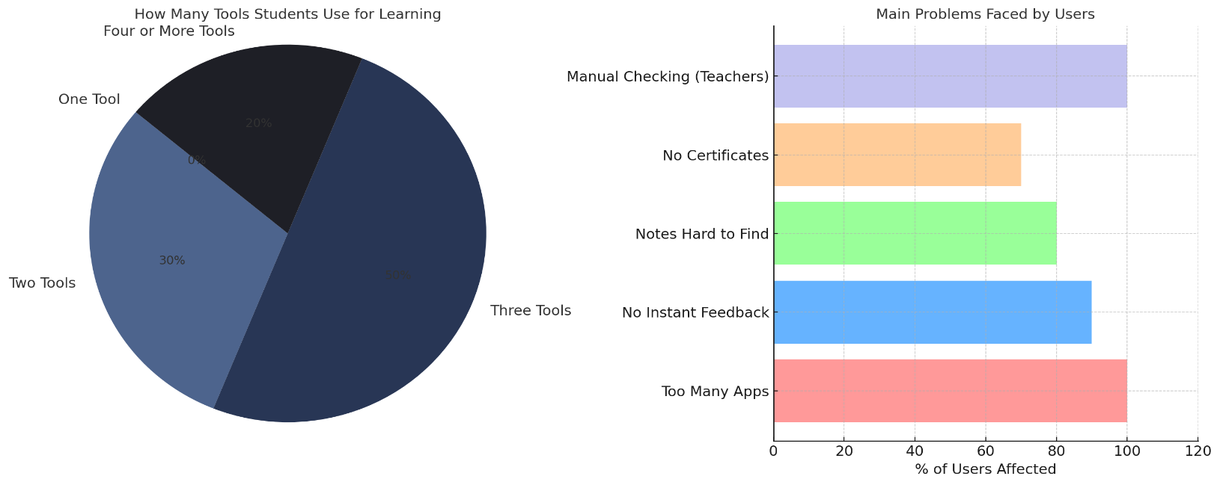

### Section 2: Finalized Project Idea

**2.1 Final Problem and Solution Statement**

**Selected Problem: Scattered Learning Experience & Lack of Instant Feedback**

After talking to students and teachers, we found a major issue in how online learning works today. Students have to use too many different apps for one course — one app for video classes, another for notes, a different one for quizzes, and maybe even another app to get certificates or ask doubts. This makes learning confusing, time-consuming, and hard to track. Teachers also said they are tired of manually checking quizzes and sending feedback. Students complained that they don’t get progress tracking or instant results, which reduces their motivation to continue learning.

**Why This Problem Matters?**

* All users we spoke to use 3–5 platforms just for one course.
* Teachers face burnout due to manual quiz checking.
* Students miss having everything in one place and often lose interest.

**What Solution Will We Build?**

We plan to build a **Mini LMS (Learning Management System)** website that puts everything in one place. This site will help small coaching classes, tutors, and individual learners to:

* Create and upload video lessons and notes
* Add quizzes with auto-grading and instant feedback
* Let students see their progress with a progress bar
* Give out PDF certificates automatically
* Include a built-in SGPA/CGPA calculator for student performance tracking
* Have a simple discussion forum for clearing doubts

**2.2 Project Type**

**Project Type: Web Application**

This project is a **Web-based Learning Management System (LMS)**. It is designed to run on any modern web browser, making it accessible on laptops, desktops, tablets, and mobile phones without needing a separate mobile app.

We chose a web application because:

* Students and teachers commonly access learning materials using browsers.
* Web apps are easier to develop, update, and maintain.
* They do not require installation from app stores.
* It works on all platforms (Windows, Android, iOS) through a single responsive design.

In the future, we can convert it into a mobile app using technologies like React Native or Flutter, but currently, it is fully focused on a responsive web app built with HTML, CSS, JavaScript, Bootstrap, Node.js, Express, and MongoDB.

**2.3 Finalized Tech Stack**

* + Frontend: HTML, CSS, JavaScript, Bootstrap

(To design the website and make it responsive)

* + Backend: Node.js, Express.js

(To manage the logic like login, courses, quizzes)

* + Database: MongoDB (MongoDB Atlas)

(To store users, courses, quiz data, progress)

**2.4 Inspiration References**

To build our Mini LMS project, we explored some popular learning apps and design platforms. These helped us understand what works well and what users like. Below are the main inspirations:

**Apps We Took Ideas From:**

1. **Khan Academy**
   * Simple course layout with videos, notes, and quizzes.
   * Instant quiz feedback and progress tracking.
2. **Duolingo**
   * Fun and clean learning flow.
   * Progress bars and streaks to motivate users.
3. **Udemy**
   * Course creation features and certificate generation.
   * Multiple content formats: video, text, quizzes.

### 

### Section 3: User Flow and Architecture

**3.1 User Flow Diagram**

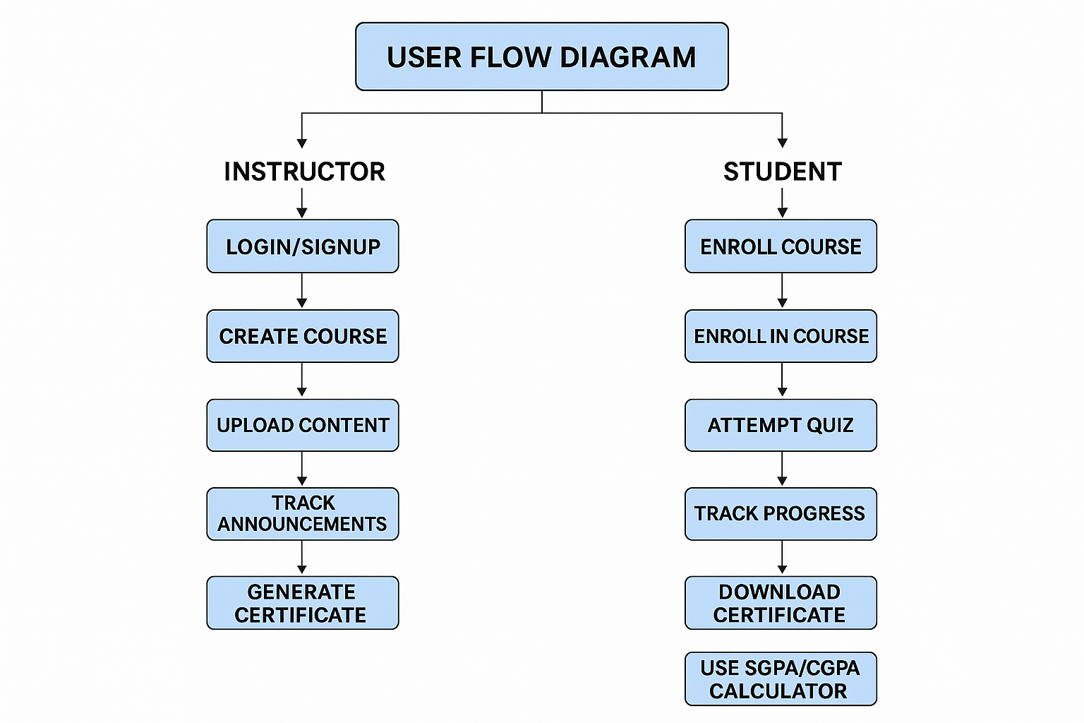

**3.2 System Architecture Diagram**

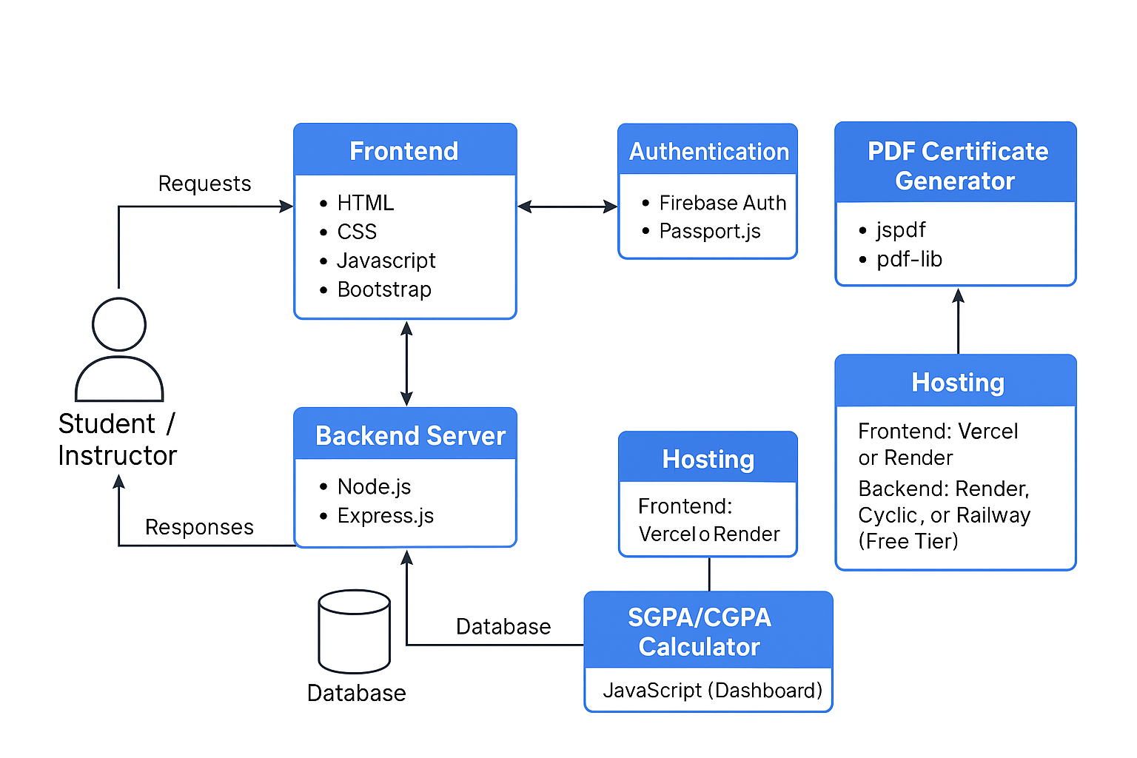

### 

### Section 4: Prototype Development

**4.1 Feature Screens**

* + Screenshots developed feature screens

* + Description of functionality

Our LMS (Learning Management System) is a web-based platform that helps students and teachers in online learning. Here's what each part does in simple steps:

**For Students:**

1. **Login/Signup:**  
   Students can create an account or log in using email or Google.
2. **Dashboard:**  
   After login, they see a simple dashboard showing enrolled courses, progress, upcoming quizzes, and announcements.
3. **Join Courses:**  
   Students can browse the list of available courses and join them with one click.
4. **Watch Lessons:**  
   Video lessons, PDFs, and notes are provided in each course module. Easy to access.
5. **Attempt Quizzes:**  
   After lessons, students can take quizzes to test their knowledge. They get instant feedback and scores.
6. **Bookmarks & Notes:**  
   They can save important topics or add personal notes to review later.
7. **Discussion Forum:**  
   If students have doubts, they can post questions or reply to others in the forum.
8. **Certificates:**  
   After completing a course, students can download a PDF certificate of completion.
9. **SGPA/CGPA Calculator:**  
   A tool is available in the dashboard to calculate their semester (SGPA) and total (CGPA) grades.

**For Instructors:**

1. **Instructor Dashboard:**  
   Teachers have a separate dashboard where they can see all their uploaded courses and student activities.
2. **Create Courses:**  
   They can upload course materials like videos, documents, and quizzes easily.
3. **Announcements:**  
   Teachers can post updates, test dates, and reminders.
4. **Manage Students:**  
   Instructors can track student progress and quiz results.

**4.2 GitHub Link**

* + Code repository (URL)- <https://github.com/saniya-salunkhe/Techspire-LMS>

**4.3 Development Challenges**

* + Issues faced and how they were solved

While building the Mini LMS project, we faced several challenges. Here’s a summary of the main problems and how we solved them:

#### 1. User Authentication & Role Management

**Problem:**  
We had to create separate dashboards and permissions for students and instructors, which made the login and routing process complex.

**Solution:**  
We used Firebase Authentication to manage login and added role-based access control in the backend. This helped us separate features based on the user type (student or instructor).

#### 2. Course Upload and File Storage

**Problem:**  
Uploading and storing videos, PDFs, and other materials securely was difficult.

**Solution:**  
We used Firebase Storage and MongoDB to handle media uploads and links. We added validations and progress indicators during uploads to avoid confusion.

#### 3. SGPA/CGPA Calculator Logic

**Problem:**  
Making a user-friendly calculator for SGPA and CGPA was confusing at first.

**Solution:**  
We created a simple input form using JavaScript and ensured correct formulas were used. We tested it with sample data to check accuracy.

#### 4. Responsive UI Design

**Problem:**  
The design looked broken on small screens and mobile phones.

**Solution:**  
We used Tailwind CSS and Flexbox/Grid layout to make sure the UI looked good on all screen sizes.

#### 5. Real-time Quiz Feedback

**Problem:**  
Giving instant feedback after quiz submission without reloading the page was tricky.

**Solution:**  
We used JavaScript and AJAX to check answers and show results instantly, making the experience smooth for students.

### 

### Section 5: Conclusion

Our team successfully built a Mini LMS Lite platform that solves the problem of scattered learning by integrating all essential features into one system. We created role-based dashboards for students and instructors, allowing easy course uploads, video lessons, notes, and quizzes. We also added unique features like a discussion forum, bookmarking, announcements, and SGPA/CGPA calculator to enhance the learning experience.

Using technologies like HTML, CSS, JavaScript, Node.js, MongoDB, and Firebase, we designed a responsive and user-friendly web platform. Along the way, we overcame challenges such as user authentication, real-time quiz feedback, and media storage.

Our next goal is to improve the system further by:

* Adding PDF certificate generation for course completion,
* Introducing AI-based quiz suggestions,
* Enabling video conferencing integration for live classes,
* And building a mobile version for better accessibility.